DAY 1 – DATA ANALYST JOURNEY
Topic: Data Understanding, Cleaning & SQL Analysis
Dataset: Superstore Sales Dataset
Tools Used: LibreOffice Calc, MySQL Workbench
- Objective of Day 1
The objective of Day 1 was to:
- Understand a real-world dataset
- Clean and standardize messy data (dates)
- Import data into MySQL
- Perform basic SQL analysis
- Think like a data analyst, not just write queries
- Dataset Description
The dataset used is a Superstore Sales Dataset, which represents sales transactions of a retail business.
Each row represents:
- One product sold in an order
Important columns used:
- Order ID
- Order Date
- Ship Date
- Region
- Category
- Sub-Category
- Sales
- Profit
- Quantit
- Initial Problem Faced
When exploring the dataset, I observed that:
- The Order Date and Ship Date columns had mixed formats, such as:
  - 11-08-2016
  - 4/15/2017
  - 2016-09-12
Because of mixed date formats:
- MySQL failed to import dates correctly
- Spreadsheet auto-formatting caused errors
This is a real-world data issue, not a beginner mistake.

- Data Cleaning in Spreadsheet (LibreOffice)
Steps followed:
- Opened the CSV file in LibreOffice Calc
- Carefully analyzed date patterns
- Split date components (day, month, year) into separate columns
- Reconstructed dates manually using logic
- Converted all dates into a single standard format
Final standardized date format:
YYYY-MM-DD
Key learning:
Automatic tools fail on messy data. Logical thinking works.

- Final Clean Dataset
After cleaning:
- All date values were consistent
- No slashes (/) or mixed formats remained
- Dataset was safe for database import
The cleaned file was saved as:
superstore_final.csv
- Creating Database and Table in MySQL
Database creation:
CREATE DATABASE data_analyst;
USE data_analyst;
Table creation:
CREATE TABLE orders (
order_id VARCHAR(50),
order_date DATE,
ship_date DATE,
region VARCHAR(50),
category VARCHAR(50),
sub_category VARCHAR(50),
sales DECIMAL(10,2),
profit DECIMAL(10,2),
quantity INT
);

- Importing Data into MySQL
Steps:
- Open MySQL Workbench
- Select the data_analyst database
- Use Table Data Import Wizard
- Import superstore_final.csv
- Fix column mapping issues (duplicate category error)
- Successfully imported all rows
Verification:
SELECT COUNT(*) FROM orders;
SELECT * FROM orders LIMIT 5;
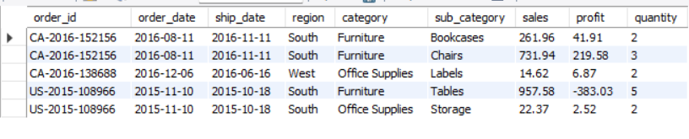
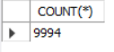
- SQL Analysis Performed
8.1 Total Sales and Profit
SELECT
ROUND(SUM(sales),2) AS total_sales,
ROUND(SUM(profit),2) AS total_profit
FROM orders;
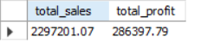

8.2 Date Range of Business
SELECT
MIN(order_date) AS first_order,
MAX(order_date) AS last_order
FROM orders;
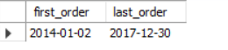
8.3 Region-wise Performance
SELECT
region,
ROUND(SUM(sales),2) AS total_sales,
ROUND(SUM(profit),2) AS total_profit
FROM orders
GROUP BY region;
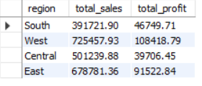

8.4 Category-wise Profit
SELECT
category,
ROUND(SUM(profit),2) AS total_profit
FROM orders
GROUP BY category
ORDER BY total_profit DESC;
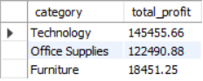
8.5 Profit Margin by Region
SELECT
region,
ROUND((SUM(profit)/SUM(sales))*100,2) AS profit_margin
FROM orders
GROUP BY region
ORDER BY profit_margin DESC;
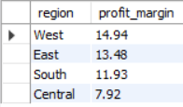

- Key Insights from Day 1
- The business operates across multiple years
- Some regions generate high sales but low profit
- Certain categories have weak profit margins
- Profit margin is a better metric than sales alone
- Business Recommendation
Based on Day 1 analysis:
- Focus on improving low-margin categories
- Investigate regions with high sales but low profit
- Optimize discount and pricing strategies
- Key Learnings from Day 1
- Real datasets are messy
- Data cleaning is more important than modeling
- SQL is not just for queries, but for insights
- Logical thinking beats tool dependency

